### **Question:**

Give an example of an application of a graph, in which determining all pairs shortest paths would be of importance. Describe what the vertices, edges and edge weights of the graph represent. Explain the significance of the shortest path for such a graph and why it would be important.

### **Graphs:**

In computer science and mathematics, a graph is a collection of vertices (also called nodes or points) and edges (also called links or lines), where each edge connects two vertices. A graph can be used to represent a wide range of real-world systems or structures, such as social networks, transportation networks, computer networks, and more.

Graphs can also have additional attributes associated with vertices or edges, such as weights or labels. These attributes can be used to represent additional information about the system being modeled.

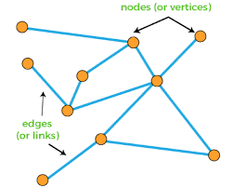

**Example:**

Google Maps Application is a perfect example of a Graph having edges, nodes and edge weights.

### **Graph Representation of Google Maps**

Google Maps can be represented as a graph with vertices, edges, and edge weights. In this graph,

**Vertex:** Each vertex represents a point of interest (POI) or an intersection.

**Edge:** Each edge represents a road or a path connecting two POIs or intersections.

**Edge Weight:** The edge weights represent the distance between two POIs or intersections.

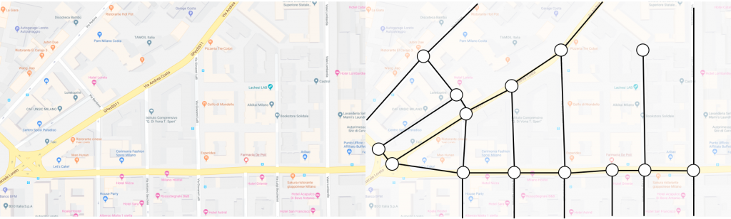

17

2.6

8

0.7

3.5

1.7

1.7

1.2

0.8

17

B

A

In the above figure, each vertex represents a POI or intersection, and each edge represents a road or path connecting two POIs or intersections. The edge weights represent the distance between two POIs or intersections in miles.

For example, the edge between vertex A and vertex B represents the road or path connecting POI A and POI B, and the edge weight represents the distance between POI A and POI B.

### Significance of Shortest Paths

The shortest path is the path between two POIs or intersections with the minimum distance. In the context of Google Maps, finding the shortest path is important because it helps users save time and fuel while traveling. For example, if a user wants to go from one POI to another POI , finding the shortest path will help the user reach 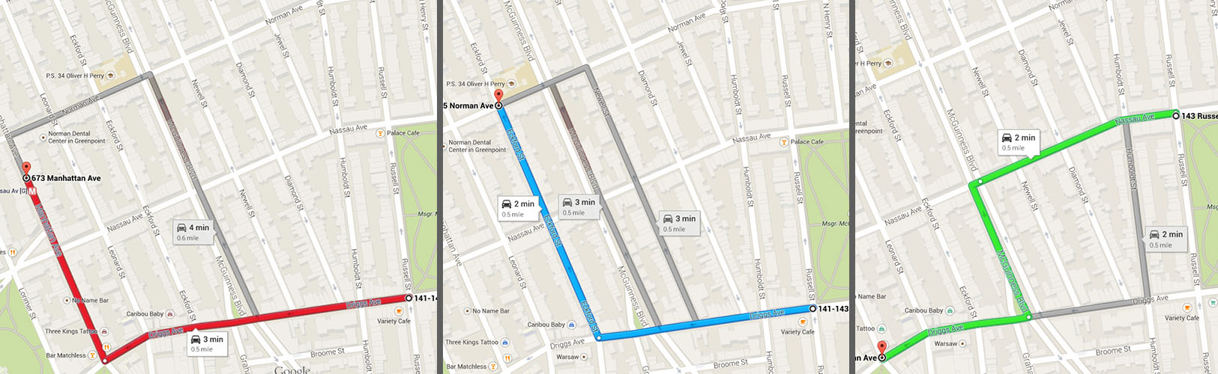the destination with minimum time and fuel consumption.

In the above figure, the three paths between between two nodes are shown. RED path denotes a path with greatest distance. BLUE path is representation of an optional distance. GREEN path denotes shortest distance path. If a user wants to travel from one POI to another POI , finding the shortest path will help the user reach the destination with minimum time and fuel consumption and in this case it will be GREEN path.

### Applications of Shortest Paths in Google Maps

Shortest paths have numerous applications in Google Maps, such as:

* Routing and Navigation: Shortest paths can be used to provide routing and navigation directions to users. Google Maps uses shortest paths to provide turn-by-turn directions to users, helping them reach their destination with minimum time and fuel consumption.
* Traffic Prediction: Shortest paths can be used to predict traffic flow and congestion. Google Maps uses historical traffic data to predict future traffic conditions and recommend the shortest path to users.
* Delivery Optimization: Shortest paths can be used to optimize delivery routes for logistics companies. By finding the shortest path between multiple delivery points, logistics companies can minimize the travel distance and time, reducing their operational costs.
* Search Results Ranking: Google Maps uses shortest path graphs to rank search results based on distance and travel time. When a user searches for a specific POI or location, Google Maps calculates the distance and travel time from the user's current location to each search result and ranks the results based on these factors.
* Map Display: Google Maps uses shortest path graphs to display the map on the user's screen. When a user zooms in or out of the map, the Google Maps system calculates the optimal set of vertices and edges to display, based on the user's current location and the scale of the map

**Conclusion:**

In conclusion, representing Google Maps as a graph and finding the shortest path between POIs or intersections is important for optimizing travel time and fuel consumption. Shortest paths have numerous applications in Google Maps, such as routing and navigation, traffic prediction, and delivery optimization.

**References:**

* https://magazine.impactscool.com/en/speciali/google-maps-e-la-teoria-dei-grafi/
* https://www.marcinkossakowski.com/posts/2014-11-03-finding-shortest-path-using-dijkstras-algorithm-and-weighed-directed-graph.html
* Cormen, T. H., Leiserson, C. E., Rivest, R. L., & Stein, C. (2009). Introduction to Algorithms (3rd ed.). MIT Press. Chapter 22: Elementary Graph Algorithms.
* Sedgewick, R., & Wayne, K. (2011). Algorithms (4th ed.). Addison-Wesley. Chapter 4: Graphs.